Setting Alignment
We have already discussed that by default, numbers are printed right justfied. For example:
1  2  3  4  5  6  7 | >>>  >>> import math  >>>  >>> print(format(math.pi, "10.2f"))  3.14  >>>  >>>
Try it now
We can change the default alignment by using following two symbols:
Symbol | Description
> | Output the value right justified within the specified width
< | Output the value left justified within the specified width
Alignment symbol must come before the specified width.
1  2  3  4 | >>>  >>> print(format(math.pi, "<10.2f")) # output the value left justfied  3.14  >>>
Here we are printing the number left justified, as a result trailing spaces are added instead of leading spaces.
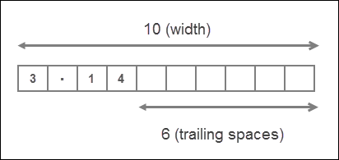
Note that the statement format(math.pi, ">10.2f") and format(math.pi, "10.2f") are same as right justified is the default format for printing numbers.

